WORKING PRINCIPLE OF STEPPER MOTOR

Stepper motor is a brushless DC electric motor that divides a full rotation into a number of equal steps.

There are two common types of stepper motors. Firstly, the “unipolar” stepper motor, and secondly, the “bipolar” stepper motor.

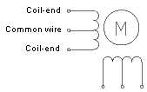

*Schematic of Unipolar Stepper Motor*

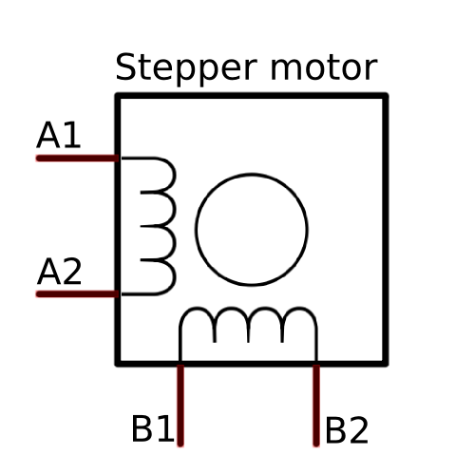

*Schematic of Bipolar Stepper Motor*

UNIPOLAR STEPPER MOTOR

1a



1c

1d

1b



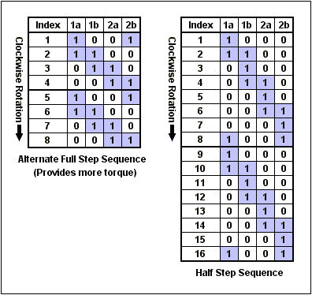

  
BIPOLAR STEPPER MOTOR

